1. Agenda:
   1. How to create microservice specific to accounts.
2. 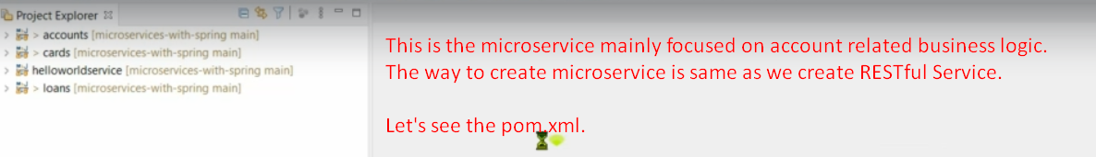
3. 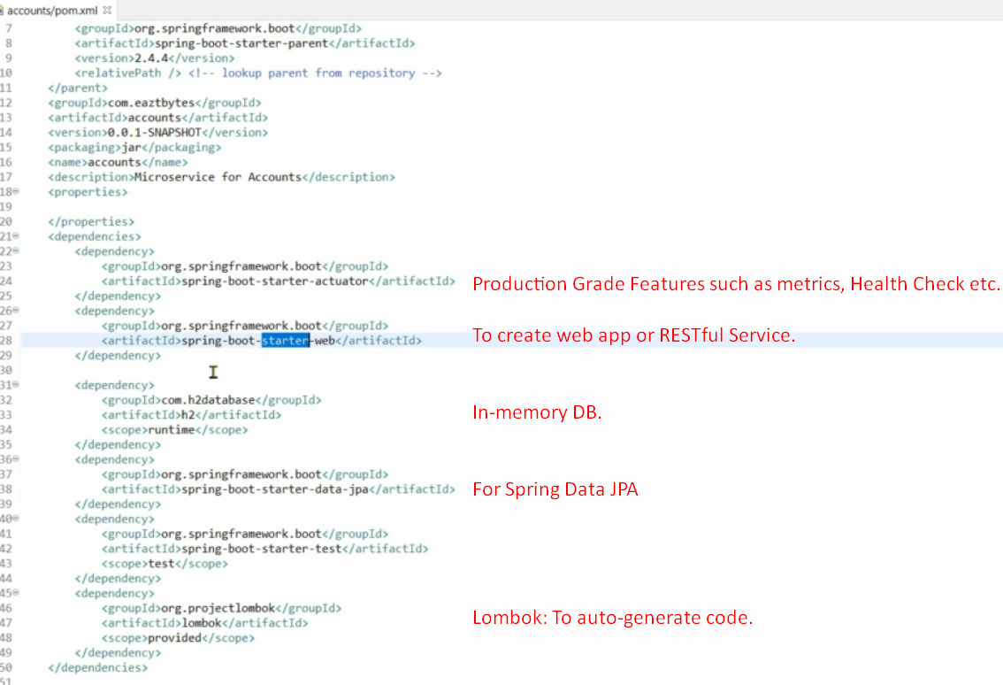
4. 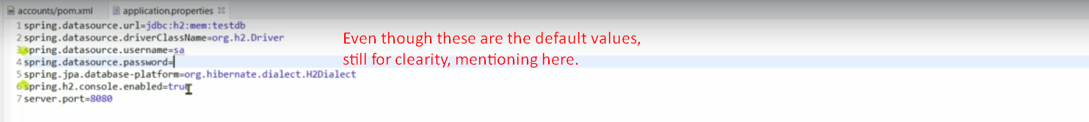
5. 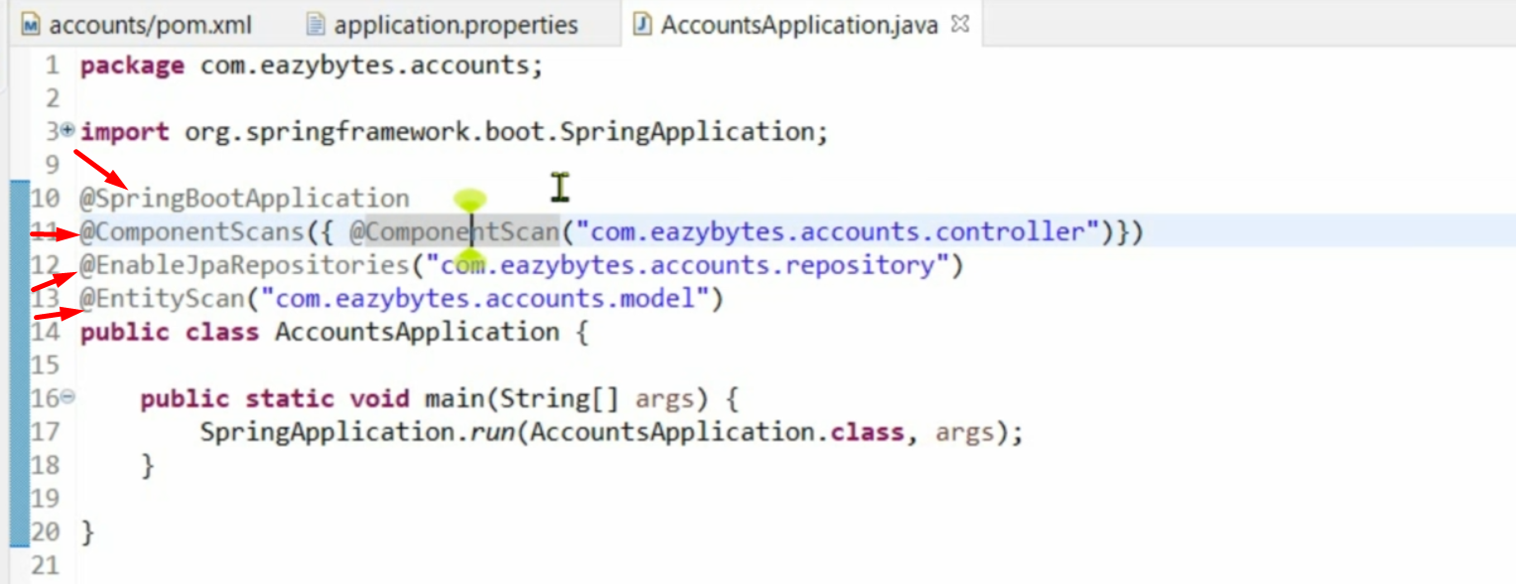
6. 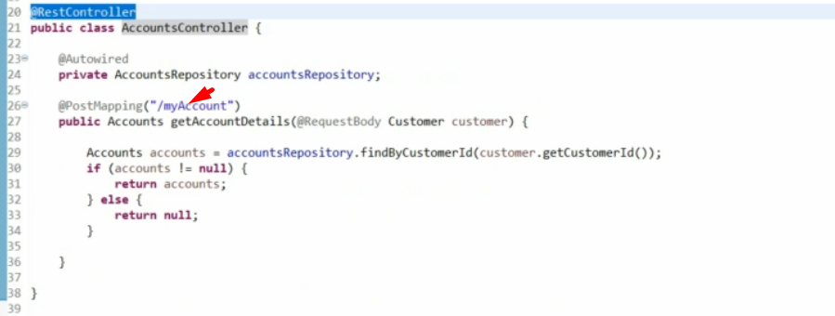
7. 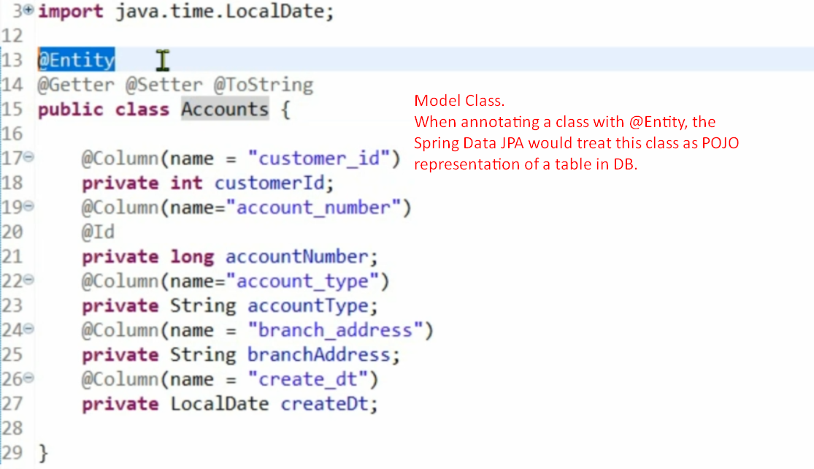
8. 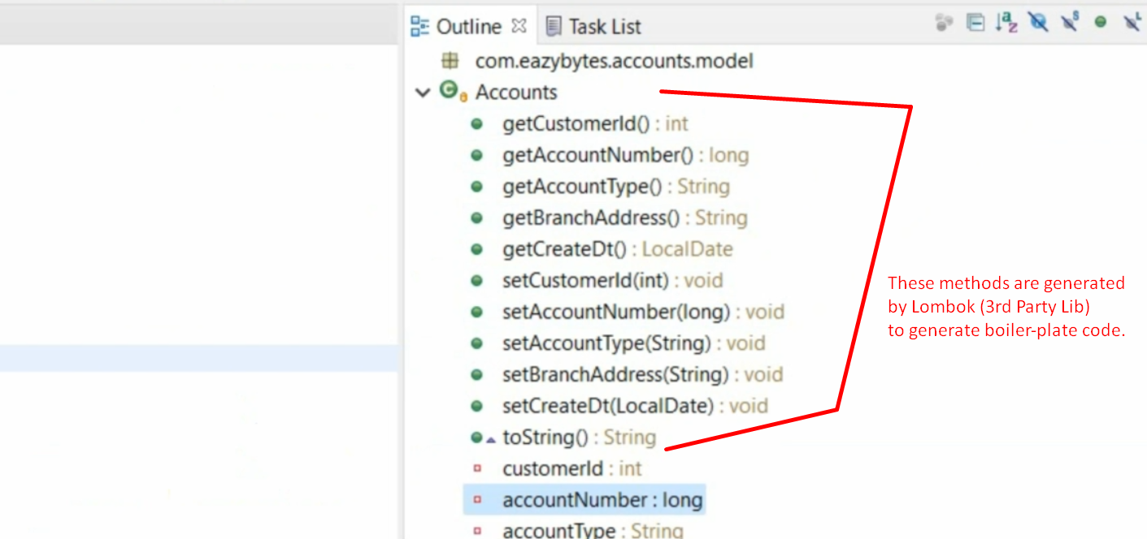
9. 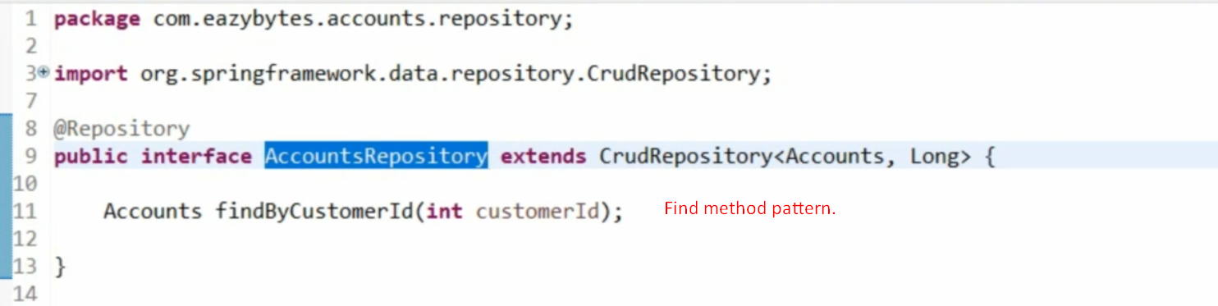
10. 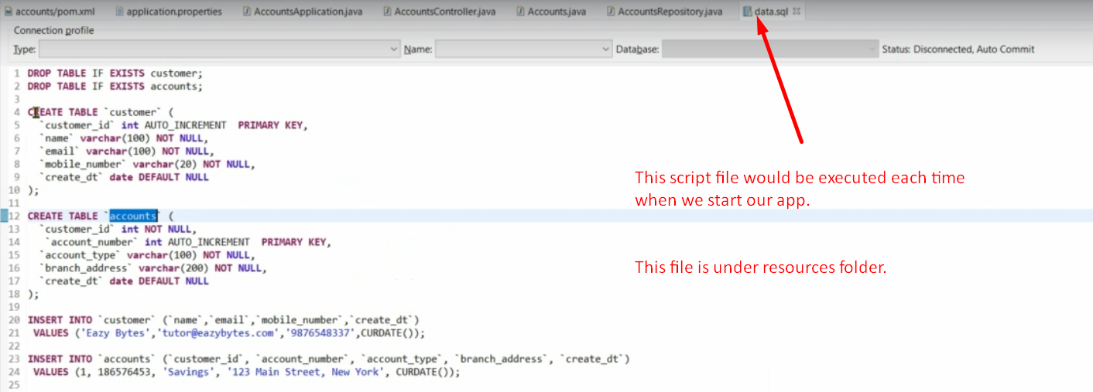
11. 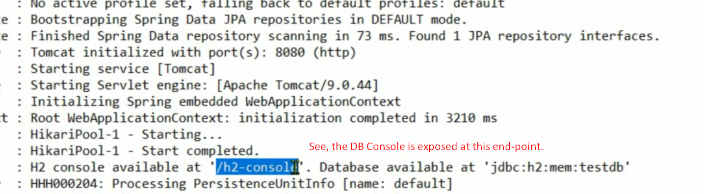
12. 
13. 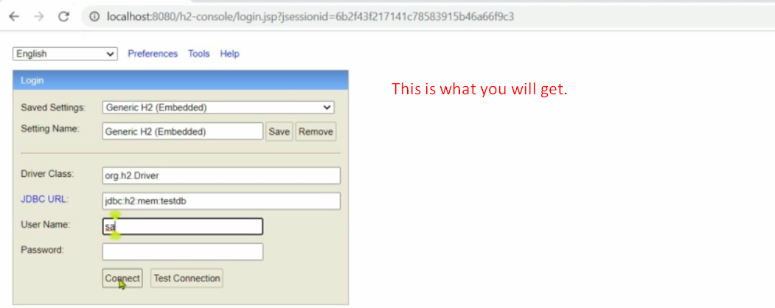
14. 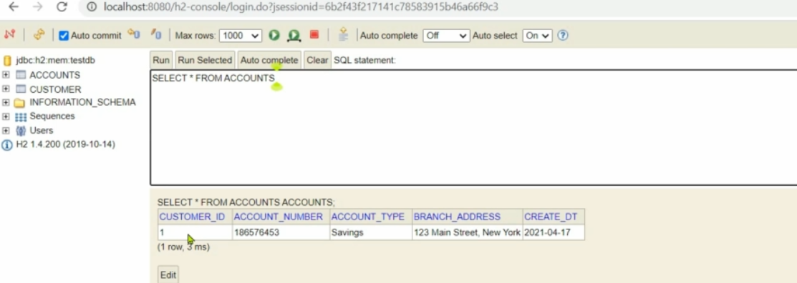
15. 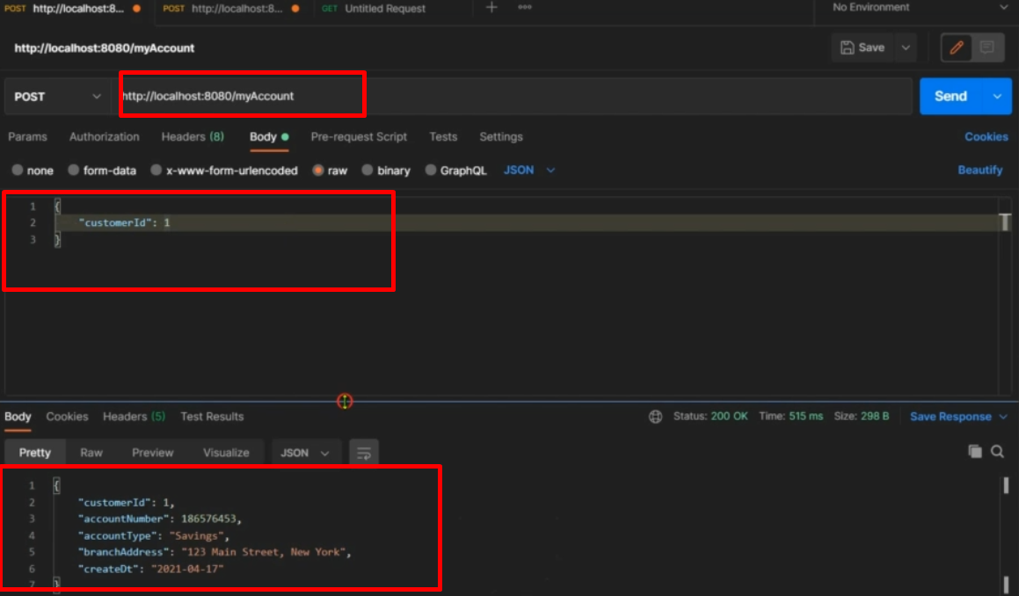
16. See, how easily we created account related microservice.
17. Along the journey, see the power of Spring Boot.
    1. How to deploy the app into a separate server.
    2. There are many starter project which cares about the dependencies and configuration.
    3. You don’t need to do much configuration.
    4. Annotations provide so much facilities such as Spring automatically identities beans, configure them, auto-wire them.